**ARYAMAN MISHRA**

**19BCE1027**

syms t

n= input('Enter the number of data points n : '); % number of x values

x_0= input('Enter the starting value of x : '); % x_1 [x(1), x(n)] x_1=x_0+s, x_2=x_1+s= x_0+2s

count = input('type 0 if the unit of x is deg. type a non-zero number otherwise');

s=input('Enter the length of the spacing between successive values of x :');

n1= input('Enter the number of harmonic of the series n1 : '); % a_1, a_2, a_{n1}

for i=1:n

x(i)=x_0+(i-1)*s;

end % x_1, x_2, x_3, .... , x_n x_2-x_1=s

if (count == 0)

x=x*pi/180;

s=s*pi/180;

end

y = input('Enter the y values (as a row vector) :') % y=[y_1 y_2 y_3 y_n]

if y(1)== y(n)

l=0.5*(x(n)-x(1)); % l=pi if it is degree function f has period 2pi

else

l=0.5*(x(n)+s-x(1));

end

a_0= (2/n)*sum(y)

for i=1:n1

yc=y.*cos(i*pi*x/l);

ys=y.*sin(i*pi*x/l);

a(i)=(2/n)*sum(yc);

b(i)=(2/n)*sum(ys);

end

F_s=a_0/2;

for i=1:n1

subplot(n1,1,i)

plot(x,y,'r*');

hold on

F_s = F_s+a(i).*cos(i*pi*t/l)+b(i).*sin(i*pi*t/l); % a(i).*cos(i*pi*t/l)+b(i).*sin(i*pi*t/l) is called fundamentals of harmonics or i^th harmonic

subplot(n1,1,i)

ezplot(F_s, [x(1) x(n)])

end

disp('Fourier series :')

vpa(F_s,4)

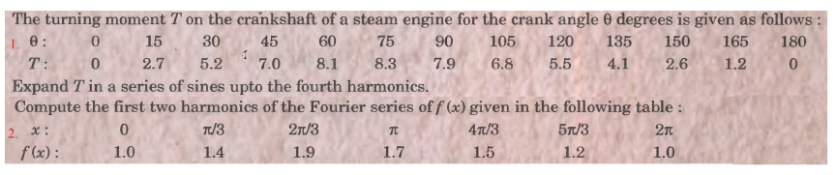

1)

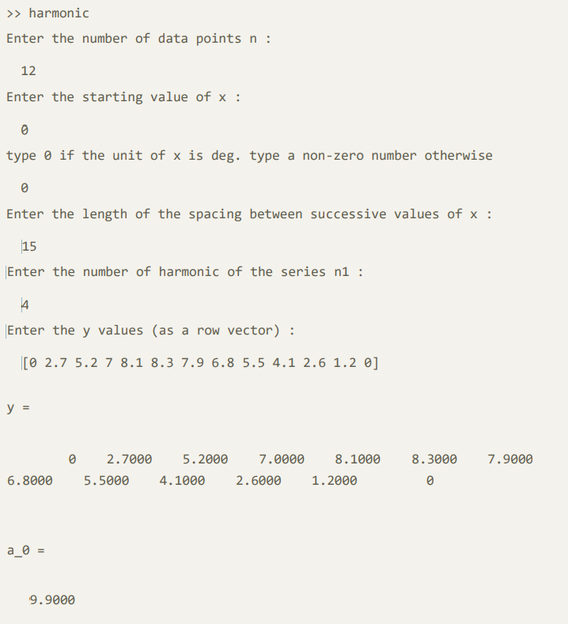

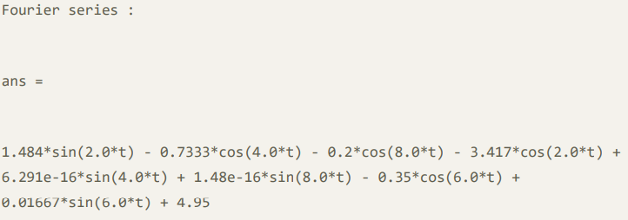

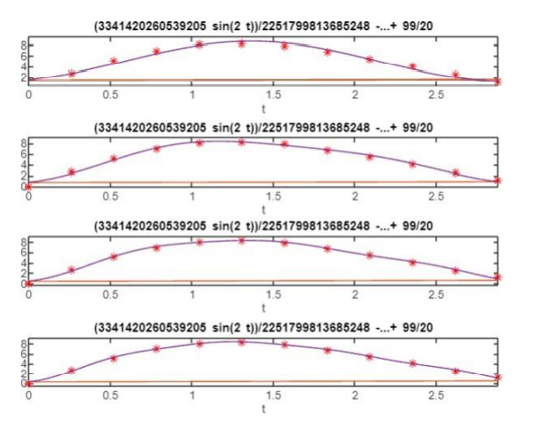

2)

